Basic of web programming

Lab-5

Name:Parmar Rahul Jayantibhai

PRN:2018033800122455

Roll no:529

Batch : B

1-Create art and craft photo album using bootstrap.

Code:

<!DOCTYPE html>

<html lang="en">

<head>

<meta charset="UTF-8">

<title>1</title>

<link rel="stylesheet" href="https://stackpath.bootstrapcdn.com/bootstrap/4.5.2/css/bootstrap.min.css">

<style>

.img{

transition: 0.9s ease-in;

}

.thumb{

transition: 0.9s ease-in;

}

.thumb:hover{

cursor: pointer;

}

.thumb:hover .img {

opacity: 0.4;

width: 101%;

}

.thumb:hover + .p{

opacity: 1;

}

</style>

</head>

<body style="background: black;color: white;text-align: center;margin: 0;padding:0;">

<h1 style="margin: 20px;">Photo Album</h1>

<h3>Here some description text</h3>

<div class="container">

<div class="row">

<div class="col-sm-3">

<div style="position: relative; height: 300px;" class=" thumb">

<img src="1.png" alt="" style="position: absolute;top: 50%;left: 50%;transform: translate(-50%,-50%);z-index: 1" class="img">

<span style="position: absolute;top: 50%;left: 50%;transform: translate(-50%,-50%);opacity: 1;" class="p">Caption</span>

</div>

</div>

<div class="col-sm-3">

<div style="position: relative; height: 300px;" class=" thumb">

<img src="2.png" alt="" style="position: absolute;top: 50%;left: 50%;transform: translate(-50%,-50%);z-index: 1" class="img">

<span style="position: absolute;top: 50%;left: 50%;transform: translate(-50%,-50%);opacity: 1;" class="p">Caption</span>

</div>

</div>

<div class="col-sm-3">

<div style="position: relative; height: 300px;" class=" thumb">

<img src="3.png" alt="" style="position: absolute;top: 50%;left: 50%;transform: translate(-50%,-50%);z-index: 1" class="img">

<span style="position: absolute;top: 50%;left: 50%;transform: translate(-50%,-50%);opacity: 1;" class="p">Caption</span>

</div>

</div>

<div class="col-sm-3">

<div style="position: relative; height: 300px;" class=" thumb">

<img src="4.png" alt="" style="position: absolute;top: 50%;left: 50%;transform: translate(-50%,-50%);z-index: 1" class="img">

<span style="position: absolute;top: 50%;left: 50%;transform: translate(-50%,-50%);opacity: 1;" class="p">Caption</span>

</div>

</div>

</div>

<div class="row">

<div class="col-sm-3">

<div style="position: relative; height: 300px;" class=" thumb">

<img src="1.png" alt="" style="position: absolute;top: 50%;left: 50%;transform: translate(-50%,-50%);z-index: 1" class="img">

<span style="position: absolute;top: 50%;left: 50%;transform: translate(-50%,-50%);opacity: 1;" class="p">Caption</span>

</div>

</div>

<div class="col-sm-3">

<div style="position: relative; height: 300px;" class=" thumb">

<img src="2.png" alt="" style="position: absolute;top: 50%;left: 50%;transform: translate(-50%,-50%);z-index: 1" class="img">

<span style="position: absolute;top: 50%;left: 50%;transform: translate(-50%,-50%);opacity: 1;" class="p">Caption</span>

</div>

</div>

<div class="col-sm-3">

<div style="position: relative; height: 300px;" class=" thumb">

<img src="3.png" alt="" style="position: absolute;top: 50%;left: 50%;transform: translate(-50%,-50%);z-index: 1" class="img">

<span style="position: absolute;top: 50%;left: 50%;transform: translate(-50%,-50%);opacity: 1;" class="p">Caption</span>

</div>

</div>

<div class="col-sm-3">

<div style="position: relative; height: 300px;" class=" thumb">

<img src="4.png" alt="" style="position: absolute;top: 50%;left: 50%;transform: translate(-50%,-50%);z-index: 1" class="img">

<span style="position: absolute;top: 50%;left: 50%;transform: translate(-50%,-50%);opacity: 1;" class="p">Caption</span>

</div>

</div>

</div>

<div class="row">

<div class="col-sm-3">

<div style="position: relative; height: 300px;" class=" thumb">

<img src="1.png" alt="" style="position: absolute;top: 50%;left: 50%;transform: translate(-50%,-50%);z-index: 1" class="img">

<span style="position: absolute;top: 50%;left: 50%;transform: translate(-50%,-50%);opacity: 1;" class="p">Caption</span>

</div>

</div>

<div class="col-sm-3">

<div style="position: relative; height: 300px;" class=" thumb">

<img src="2.png" alt="" style="position: absolute;top: 50%;left: 50%;transform: translate(-50%,-50%);z-index: 1" class="img">

<span style="position: absolute;top: 50%;left: 50%;transform: translate(-50%,-50%);opacity: 1;" class="p">Caption</span>

</div>

</div>

<div class="col-sm-3">

<div style="position: relative; height: 300px;" class=" thumb">

<img src="3.png" alt="" style="position: absolute;top: 50%;left: 50%;transform: translate(-50%,-50%);z-index: 1" class="img">

<span style="position: absolute;top: 50%;left: 50%;transform: translate(-50%,-50%);opacity: 1;" class="p">Caption</span>

</div>

</div>

<div class="col-sm-3">

<div style="position: relative; height: 300px;" class=" thumb">

<img src="4.png" alt="" style="position: absolute;top: 50%;left: 50%;transform: translate(-50%,-50%);z-index: 1" class="img">

<span style="position: absolute;top: 50%;left: 50%;transform: translate(-50%,-50%);opacity: 1;" class="p">Caption</span>

</div>

</div>

</div>

</div>

</body>

</html>

Output:

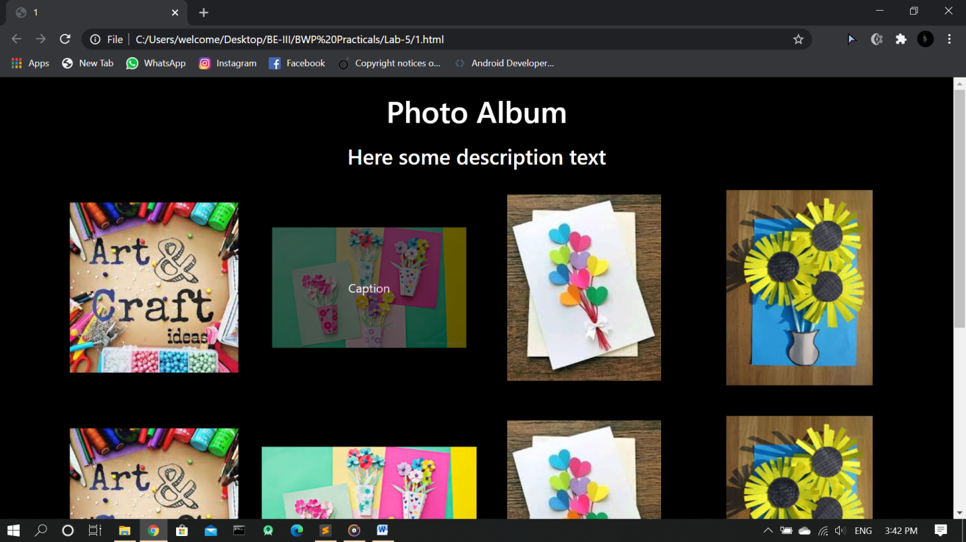

2-Create student marksheet using bootstrap.

Code:

<!DOCTYPE html>

<html lang="en">

<head>

<meta charset="UTF-8">

<title>2</title>

<link rel="stylesheet" href="https://stackpath.bootstrapcdn.com/bootstrap/4.5.2/css/bootstrap.min.css">

</head>

<body style="background: white;margin: 0 200px;padding: 0;color: black;">

<h1 style="margin: 20px;text-align: center;"><img src="image1.png" alt="" width="80" style="top: 50%;"> &nbsp; &nbsp;The Maharaja Sayajirav University of Baroda</h1>

<h6 style="text-align: center;">Vadodara-390002,Gujarat,India</h6>

<hr style="background: white;margin: 20px">

<div class="row">

<div class="col-md-8" style="text-align: center;"><p style="margin: 20px;position: absolute;top: 50%;transform: translate(0%,-70%);">Statement of Marks for Second Semester of BE-I(Computer Science)

Faculty of Technology & Engineering - Bachelor of Engineering

Examination:Aprll-2019</p></div>

<div class="col-md-4" style="text-align: center;">

<div style="margin: 20px;background: black;height: 100px;width: 100px;">

</div>

</div>

</div>

<hr style="background: white;margin: 20px">

<div class="row" style="margin: 20px;">

<div class="col-md-8">

<p>

Name: &nbsp;PARMAR RAHUL JAYANTIBHAI <br>

Mother Name: &nbsp;BHARTIBEN <br>

PRN:&nbsp; 2018033800122455 <br>

</p>

</div>

<div class="col-md-4" style="vertical-align: middle;">

Seat no:&nbsp;304037

</div>

</div>

<table class="table table-bordered">

<thead>

<tr>

<th rowspan="2">

Course Code</th>

<th rowspan="2"> Course Name</th>

<th rowspan="2">AM</th>

<th colspan="3"> UA</th>

<th colspan="3"> IA</th>

<th colspan="3"> Total</th>

<th rowspan="2">Sts</th>

<th rowspan="2">Rmk</th>

</tr>

<tr>

<th>MAX</th>

<th>MIN</th>

<th>OBT</th>

<th>MAX</th>

<th>MIN</th>

<th>OBT</th>

<th>MAX</th>

<th>MIN</th>

<th>OBT</th>

</tr>

</thead>

<tbody>

<tr>

<th>APM1202</th>

<td> Engineering Mechanics</td>

<td>TH</td>

<td>100</td>

<td>-</td>

<td>75</td>

<td>-</td>

<td>-</td>

<td>-</td>

<td>100</td>

<td>40</td>

<td>75</td>

<td>P</td>

<td>E,C</td>

</tr>

<tr>

<th>APM1202</th>

<td> Engineering Mechanics</td>

<td>TH</td>

<td>100</td>

<td>-</td>

<td>75</td>

<td>-</td>

<td>-</td>

<td>-</td>

<td>100</td>

<td>40</td>

<td>75</td>

<td>P</td>

<td>E,C</td>

</tr>

<tr>

<th>APM1202</th>

<td> Engineering Mechanics</td>

<td>TH</td>

<td>100</td>

<td>-</td>

<td>75</td>

<td>-</td>

<td>-</td>

<td>-</td>

<td>100</td>

<td>40</td>

<td>75</td>

<td>P</td>

<td>E,C</td>

</tr>

<tr>

<th>APM1202</th>

<td> Engineering Mechanics</td>

<td>TH</td>

<td>100</td>

<td>-</td>

<td>75</td>

<td>-</td>

<td>-</td>

<td>-</td>

<td>100</td>

<td>40</td>

<td>75</td>

<td>P</td>

<td>E,C</td>

</tr>

<tr>

<th>APM1202</th>

<td> Engineering Mechanics</td>

<td>TH</td>

<td>100</td>

<td>-</td>

<td>75</td>

<td>-</td>

<td>-</td>

<td>-</td>

<td>100</td>

<td>40</td>

<td>75</td>

<td>P</td>

<td>E,C</td>

</tr>

<tr>

<th>APM1202</th>

<td> Engineering Mechanics</td>

<td>TH</td>

<td>100</td>

<td>-</td>

<td>75</td>

<td>-</td>

<td>-</td>

<td>-</td>

<td>100</td>

<td>40</td>

<td>75</td>

<td>P</td>

<td>E,C</td>

</tr>

<tr>

<th>APM1202</th>

<td> Engineering Mechanics</td>

<td>TH</td>

<td>100</td>

<td>-</td>

<td>75</td>

<td>-</td>

<td>-</td>

<td>-</td>

<td>100</td>

<td>40</td>

<td>75</td>

<td>P</td>

<td>E,C</td>

</tr>

<tr>

<th>APM1202</th>

<td> Engineering Mechanics</td>

<td>TH</td>

<td>100</td>

<td>-</td>

<td>75</td>

<td>-</td>

<td>-</td>

<td>-</td>

<td>100</td>

<td>40</td>

<td>75</td>

<td>P</td>

<td>E,C</td>

</tr>

<tr>

<th>APM1202</th>

<td> Engineering Mechanics</td>

<td>TH</td>

<td>100</td>

<td>-</td>

<td>75</td>

<td>-</td>

<td>-</td>

<td>-</td>

<td>100</td>

<td>40</td>

<td>75</td>

<td>P</td>

<td>E,C</td>

</tr>

<tr>

<th colspan="5">Total</th>

<th >548</th>

<th colspan="5"></th>

<th>548</th>

<th colspan="2"></th>

</tr>

<tr>

<td colspan="14">

Grand Total:1037 out of 1400 <br>

<br>

Result:Pass &nbsp;&nbsp;&nbsp; Class:Distication &nbsp;&nbsp;&nbsp; Percentage:74.07%

</td>

</tr>

<tr>

<td colspan="14">

Abbreviations:IA

</td>

</tr>

</tbody>

</table>

</body>

</html>

Output:

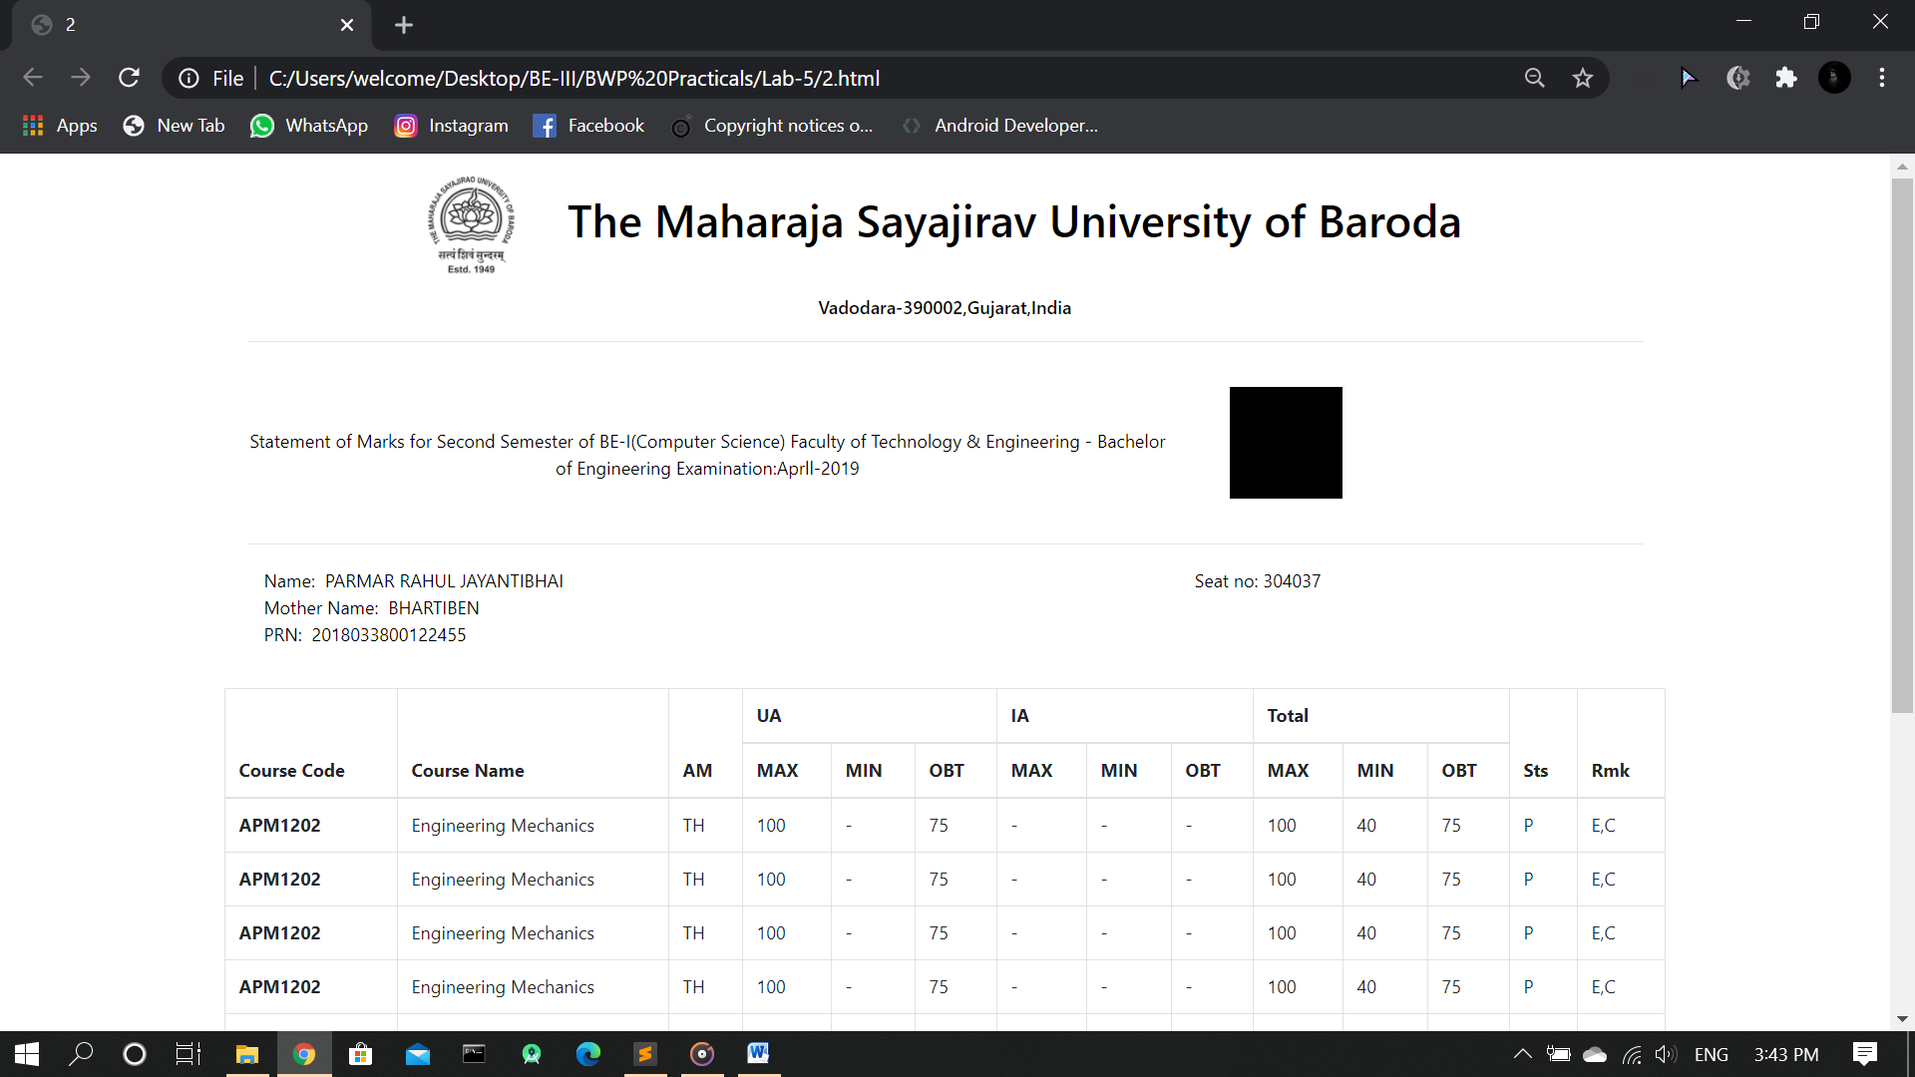

3-Create employment application form like below

Code:

<!DOCTYPE html>

<html lang="en">

<head>

<meta charset="UTF-8">

<title>3</title>

<meta name="viewport" content="width=device-width, initial-scale=1, shrink-to-fit=no">

<link rel="stylesheet" href="https://stackpath.bootstrapcdn.com/bootstrap/4.5.2/css/bootstrap.min.css">

<style>

hr{

background: black;

padding: .1px;

}

</style>

</head>

<body style="margin: 0;padding: 0;">

<div style="margin: 30px;background-color: white;">

<h3 style="background: blue;color: white;padding: 5px;text-align: center;">PLEASE PRINT ALL INFORMATION REQUESTED EXCEPT SIGNATURE</h3>

<h5 style="text-align: center;">APPLICANT MAY BE TESTED FOR ILLEGAL DRUGS</h5>

<hr >

<div class="row">

<div class="col-sm-8">

<p >PLEASE COMPLETE PAGES 1-5.</p>

</div>

<div class="col-sm-4">

<p>Date: &nbsp;<input type="Date"></p>

</div>

</div>

<hr>

<p>NAME: &nbsp; <input type="text" style="width: 90%"></p>

<hr>

<div class="row">

<div class="col-sm-3" style="text-align: center;">

Last

</div>

<div class="col-sm-3" style="text-align: center;">

First

</div>

<div class="col-sm-3" style="text-align: center;">

Middle

</div>

<div class="col-sm-3" style="text-align: center;">

Maiden

</div>

</div>

<hr>

<p>Present Address: &nbsp; <input type="text" style="width: 80%"></p>

<hr>

<div class="row">

<div class="col-sm-2" style="text-align: center;">

Number

</div>

<div class="col-sm-2" style="text-align: center;">

Street

</div>

<div class="col-sm-2" style="text-align: center;">

City

</div>

<div class="col-sm-2" style="text-align: center;">

State

</div>

<div class="col-sm-2" style="text-align: center;">

Zip

</div>

</div>

<hr>

<div class="row">

<div class="col-sm-7">

<p>How long: &nbsp; <input type="text" style="width: 50%"></p>

</div>

<div class="col-sm-5">

<p>Social Security No: &nbsp; <input type="text" style="width: 50%"></p>

</div>

</div>

<hr>

<p>Telephone: &nbsp; <input type="text" style="width: 80%"></p>

<hr>

<p>If Under 18 please list age: &nbsp; <input type="text" style="width: 60%"></p>

<hr>

<div class="row">

<div class="col-sm-5">

<p>Position Applied for: &nbsp; <input type="text" style="width: 60%"></p>

<hr>

<p>Salary Desired: &nbsp; <input type="text" style="width: 60%"></p>

</div>

<div class="col-sm-7">

Days/Hours Available to Work: <br>

<p>No Pref: &nbsp; <input type="checkbox"> &nbsp;&nbsp;Thur: &nbsp; <input type="checkbox"> </p>

<p>Mon: &nbsp; <input type="checkbox">&nbsp;&nbsp; Fri: &nbsp; <input type="checkbox"> </p>

<p>Tue: &nbsp; <input type="checkbox">&nbsp;&nbsp; Sat: &nbsp; <input type="checkbox"> </p>

<p>Wedn: &nbsp; <input type="checkbox">&nbsp;&nbsp; Sun: &nbsp; <input type="checkbox"> </p>

</div>

</div>

<hr>

<div class="row">

<div class="col-sm-6">

How many hours can you work weekly?

<input type="text">

</div>

<div class="col-sm-6">

Can you work nights?

<input type="text">

</div>

</div>

<hr>

<p>Employment Desired : &nbsp; <input type="radio"> &nbsp;Full-Time &nbsp; <input type="radio"> &nbsp;Part-Time &nbsp; <input type="radio"> &nbsp;Full-Time or Part-Time </p>

<hr>

<p>When Available for Work: &nbsp; <input type="text" style="width: 80%"></p>

<table class="table table-striped table-bordered" >

<tbody>

<tr>

<th colspan="5" style="text-align: center;">EDUCATION AND OTHER INFORMATION</th>

</tr>

<tr>

<th>TYPE OF SCHOOL</th>

<th>NAME OF SCHOOL</th>

<th>LOCATION <br>(Complete mailing address)</th>

<th>NO.OF YEARS COMPLETED </th>

<th>MAJOR &AMP; DEGREE</th>

</tr>

<tr>

<th colspan="5">HIGH SCHOOL</th>

</tr>

<tr>

<td><input type="text"></td>

<td><input type="text"></td>

<td><input type="text"></td>

<td><input type="text"></td>

<td><input type="text"></td>

</tr>

<tr>

<th colspan="5">COLLEGE</th>

</tr>

<tr>

<td><input type="text"></td>

<td><input type="text"></td>

<td><input type="text"></td>

<td><input type="text"></td>

<td><input type="text"></td>

</tr>

<tr>

<th colspan="5">BUS. OR TRADE SCHOOL</th>

</tr>

<tr>

<td><input type="text"></td>

<td><input type="text"></td>

<td><input type="text"></td>

<td><input type="text"></td>

<td><input type="text"></td>

</tr>

<tr>

<th colspan="5">PROFESSIONAL SCHOOL</th>

</tr>

<tr>

<td><input type="text"></td>

<td><input type="text"></td>

<td><input type="text"></td>

<td><input type="text"></td>

<td><input type="text"></td>

</tr>

</tbody>

</table>

</div>

</body>

</html>

Output:

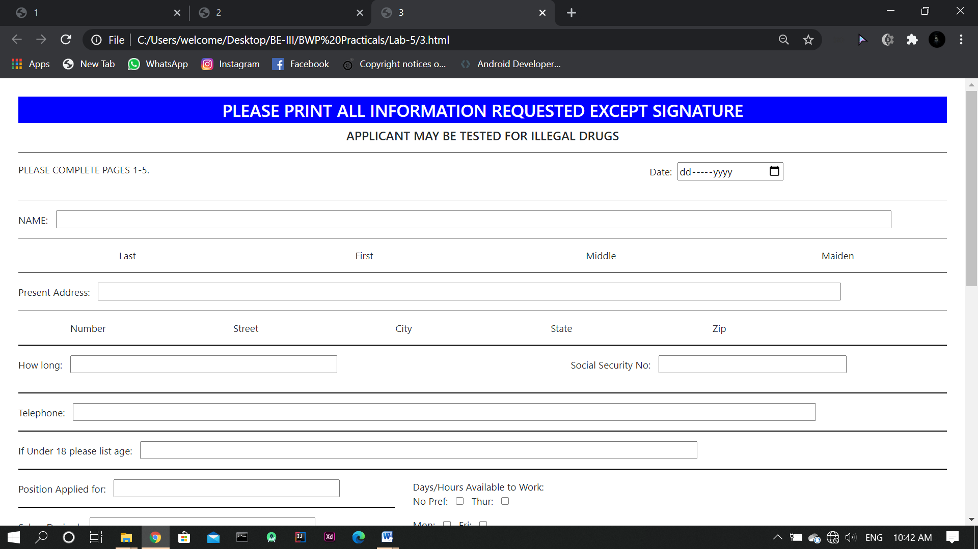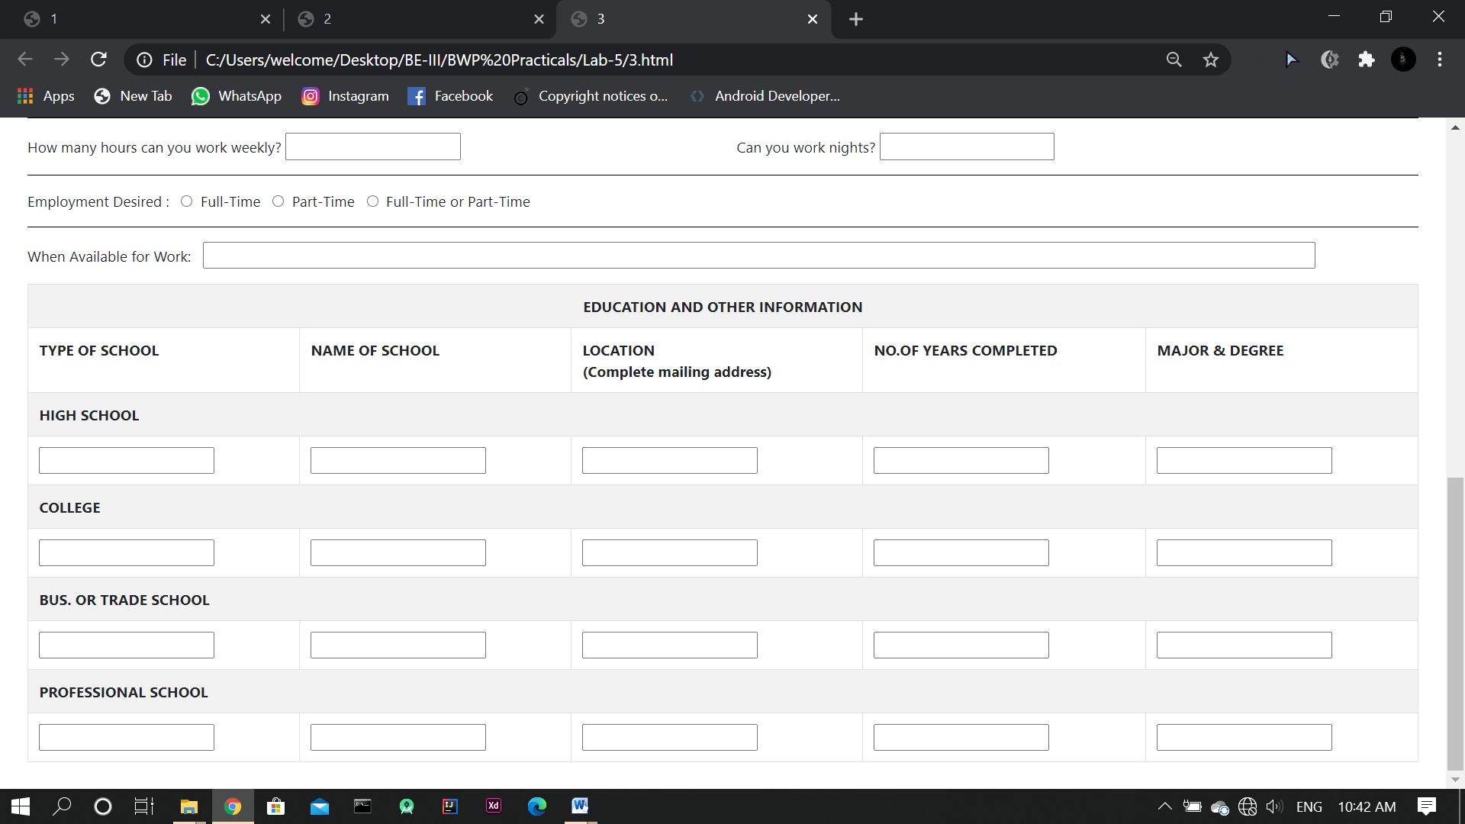

4-Design home of flipKart in which Navigation bar with dropdown is available using bootstrap.

Code:

<!DOCTYPE html>

<html lang="en">

<head>

<title>4 flipkart</title>

<meta charset="utf-8">

<meta name="viewport" content="width=device-width, initial-scale=1">

<link rel="stylesheet" href="https://maxcdn.bootstrapcdn.com/bootstrap/4.5.2/css/bootstrap.min.css">

<script src="https://ajax.googleapis.com/ajax/libs/jquery/3.5.1/jquery.min.js"></script>

<script src="https://cdnjs.cloudflare.com/ajax/libs/popper.js/1.16.0/umd/popper.min.js"></script>

<script src="https://maxcdn.bootstrapcdn.com/bootstrap/4.5.2/js/bootstrap.min.js"></script>

<style>

body{

background: #F3F3F3;

}

.navlink{

color: white;

}

ul{

list-style-type: none;

}

.dlink{

margin: 15px;

color: black;

padding:2px;

text-decoration: none;

}

.dlink:hover{

text-decoration: none;

background: #2874F0;

color: white;

}

.carousel-inner img {

width: 100%;

height: 60vh;

text-align: center;

}

</style>

</head>

<body>

<nav class="navbar navbar-expand-sm navbar-dark justify-content-center" style="background: #2874F0;">

<a class="navbar-brand navlink" href="#"><img src="logo.png" alt="" width="60">

<span style="font-size: 10px">Explore <img src="plus.png" alt="" width="10"> </span></a>

<form class="form-inline" action="#">

<input class=" mr-2 p-1" type="text" placeholder="Search" style="border: none;">

<button class="btn mr-2 " style="background: white;color: #2874F0" type="submit">Search</button>

</form>

<button class="navbar-toggler" type="button" data-toggle="collapse" data-target="#collapsibleNavbar" style="border: 1px solid white;color: white">

<span class="navbar-toggler-icon" style="color: white"></span>

</button>

<div class="collapse navbar-collapse justify-content-center" id="collapsibleNavbar">

<ul class="navbar-nav">

<li class="nav-item">

<button class="btn mr-2" style="background: white;color: #2874F0;margin: 10px">Login</button>

</li>

<li class="nav-item">

<div class="dropdown">

<button type="button" class="btn mr-2 dropdown-toggle" data-toggle="dropdown" style="background: #2874F0;color:white;margin: 10px">

More

</button>

<div class="dropdown-menu">

<a class="dropdown-item" href="#">Notification Preference</a>

<a class="dropdown-item" href="#">Sell on Flipkart</a>

<a class="dropdown-item" href="#">24 \* 7 Customer care</a>

<a class="dropdown-item" href="#">Advertise</a>

<a class="dropdown-item" href="#">Download App</a>

</div>

</div>

</li>

<li class="nav-item">

<button class="btn mr-2" style="background: #2874F0;color:white;margin: 10px">Cart</button>

</li>

</ul>

</div>

</nav>

<div class="container" style="background: #F3F3F3">

<div class="row" style="margin-top: 10px;">

<div class="col-sm-3">

<button type="button" class="btn" data-toggle="collapse" data-target="#abc">Electronics &#10095;</button>

</div>

<div class="col-sm-3">

<button type="button" class="btn" data-toggle="collapse" data-target="#abcd">TVs &amp; Appliances&#10095;</button>

</div>

<div class="col-sm-3">

<button type="button" class="btn" data-toggle="collapse" data-target="#men">Men &#10095;</button>

</div>

<div class="col-sm-3">

<button type="button" class="btn" data-toggle="collapse" data-target="#men">Women &#10095;</button>

</div>

</div>

<div class="collapse" id="abc" style="margin-top: 10px;width: 90vw">

<div class="row">

<div class="col-sm-4">

<ul>

<li><a href="" class="dlink"><b>Mobiles</b></a></li>

<li><a href="" class="dlink">Mi</a></li>

<li><a href="" class="dlink">Realme</a></li>

<li><a href="" class="dlink">Oppo</a></li>

<li><a href="" class="dlink">Poco</a></li>

<li><a href="" class="dlink">Apple</a></li>

<li><a href="" class="dlink">Vivo</a></li>

<li><a href="" class="dlink">Honor</a></li>

<li><a href="" class="dlink">Asus</a></li>

<li><a href="" class="dlink">Motorola</a></li>

</ul>

</div>

<div class="col-sm-4">

<ul>

<li><a href="" class="dlink"><b>Mobile Accessories</b></a></li>

<li><a href="" class="dlink">Mobile Cases</a></li>

<li><a href="" class="dlink">Headphones</a></li>

<li><a href="" class="dlink">Power banks</a></li>

<li><a href="" class="dlink">Charger</a></li>

<li><a href="" class="dlink">Earphones</a></li>

<li><a href="" class="dlink">Covers</a></li>

<li><a href="" class="dlink">Smart Watches</a></li>

<li><a href="" class="dlink">Mobile Holders</a></li>

<li><a href="" class="dlink">Cabels</a></li>

<li><a href="" class="dlink">Screen Guards</a></li>

</ul>

</div>

<div class="col-sm-4">

<ul>

<li><a href="" class="dlink"><b>Laptop</b></a></li>

<li><a href="" class="dlink">Gaming Laptops</a></li>

<li><a href="" class="dlink">External Hard disk</a></li>

<li><a href="" class="dlink">Pendrives</a></li>

<li><a href="" class="dlink">Bags</a></li>

<li><a href="" class="dlink">Mouses</a></li>

</ul>

</div>

</div>

</div>

<div class="collapse" id="abcd" style="margin-top: 10px;width: 90vw">

<div class="row">

<div class="col-sm-4">

<ul>

<li><a href="" class="dlink"><b>TVs</b></a></li>

<li><a href="" class="dlink">Mi</a></li>

<li><a href="" class="dlink">Realme</a></li>

<li><a href="" class="dlink">Samsung</a></li>

<li><a href="" class="dlink">Vu</a></li>

<li><a href="" class="dlink">LG</a></li>

<li><a href="" class="dlink">Motorola</a></li>

<li><a href="" class="dlink">Nokia</a></li>

</ul>

</div>

<div class="col-sm-4">

<ul>

<li><a href="" class="dlink"><b>Washing Machine</b></a></li>

<li><a href="" class="dlink">Fully Automatic</a></li>

<li><a href="" class="dlink">Semi Automatic</a></li>

<li><a href="" class="dlink">Front Load</a></li>

<li><a href="" class="dlink">Top Load</a></li>

<li><a href="" class="dlink"><b>AC</b></a></li>

<li><a href="" class="dlink">Inverter</a></li>

<li><a href="" class="dlink">Window</a></li>

<li><a href="" class="dlink">Split</a></li>

</ul>

</div>

<div class="col-sm-4">

<ul>

<li><a href="" class="dlink"><b>Laptop</b></a></li>

<li><a href="" class="dlink">Gaming Laptops</a></li>

<li><a href="" class="dlink">External Hard disk</a></li>

<li><a href="" class="dlink">Pendrives</a></li>

<li><a href="" class="dlink">Bags</a></li>

<li><a href="" class="dlink">Mouses</a></li>

</ul>

</div>

</div>

</div>

<div class="collapse" id="men" style="margin-top: 10px;width: 90vw">

<div class="row">

<div class="col-sm-4">

<ul>

<li><a href="" class="dlink"><b>Foot Wear</b></a></li>

<li><a href="" class="dlink">Sandels</a></li>

<li><a href="" class="dlink">Formal</a></li>

<li><a href="" class="dlink">Casual</a></li>

<li><a href="" class="dlink">Sports</a></li>

<li><a href="" class="dlink"><b>Grooming</b></a></li>

<li><a href="" class="dlink">Deodaoronats</a></li>

<li><a href="" class="dlink">Perfume</a></li>

</ul>

</div>

<div class="col-sm-4">

<ul>

<li><a href="" class="dlink"><b>Bottom Wear</b></a></li>

<li><a href="" class="dlink">Jeans</a></li>

<li><a href="" class="dlink">Capris</a></li>

<li><a href="" class="dlink">Formal pants</a></li>

<li><a href="" class="dlink">Tracks</a></li>

<li><a href="" class="dlink"><b>Top Wear</b></a></li>

<li><a href="" class="dlink">T-shirts</a></li>

<li><a href="" class="dlink">Cacual Shirts</a></li>

<li><a href="" class="dlink">Formal Shirts</a></li>

</ul>

</div>

<div class="col-sm-4">

<ul>

<li><a href="" class="dlink"><b>Watches</b></a></li>

<li><a href="" class="dlink">Fasttrack</a></li>

<li><a href="" class="dlink">Casio</a></li>

<li><a href="" class="dlink">Titen</a></li>

<li><a href="" class="dlink">Fossil</a></li>

<li><a href="" class="dlink">Sanota</a></li>

</ul>

</div>

</div>

</div>

<hr>

<div id="demo" class="carousel slide" data-ride="carousel">

<!-- Indicators -->

<ul class="carousel-indicators justify-content-center">

<li data-target="#demo" data-slide-to="0" class="active"></li>

<li data-target="#demo" data-slide-to="1"></li>

<li data-target="#demo" data-slide-to="2"></li>

</ul>

<!-- The slideshow -->

<div class="carousel-inner ju">

<div class="carousel-item active">

<img src="slide.jpg" alt="Los Angeles">

</div>

<div class="carousel-item">

<img src="slide2.jpg" alt="Chicago">

</div>

<div class="carousel-item">

<img src="slide3.jpg" alt="New York">

</div>

</div>

<!-- Left and right controls -->

<a class="carousel-control-prev" href="#demo" data-slide="prev">

<span class="carousel-control-prev-icon"></span>

</a>

<a class="carousel-control-next" href="#demo" data-slide="next">

<span class="carousel-control-next-icon"></span>

</a>

</div>

<hr>

<div>

<div class="row" style="height: 80px;">

<div class="col-9">

<h3>Deals of the day</h3>

<span style="color: grey;">upto 70& off</span>

</div>

<div class="col-3" style="height: 100%">

<a href="#" style="text-decoration: none;padding: 10px;background: #2874F0;color: white;position: absolute;top: 50%;transform: translateY(-50%);">View all</a>

</div>

</div>

<hr>

<div class="row">

<div class="col-sm-2 col-6" style="text-align: center;">

<img src="item.png" alt="" height="150px"><br>

<p style="font-weight: bold;">Office study tables</p>

<p style="color: green;">From $200</p>

<p style="color: grey">Made in India Brands</p>

</div>

<div class="col-sm-2 col-6" style="text-align: center;">

<img src="https://rukminim1.flixcart.com/image/300/300/k5h2jrk0/speaker/mobile-tablet-speaker/f/k/b/mivi-bs3zr-bk-original-imafz59evywgxmhr.jpeg?q=70" alt="" height="150px"><br>

<p style="font-weight: bold;">Speakers</p>

<p style="color: green;">From $200</p>

<p style="color: grey">Made in India Brands</p>

</div>

<div class="col-sm-2 col-6" style="text-align: center;">

<img src="https://rukminim1.flixcart.com/image/300/300/jzrb53k0pkrrdj/smartwatch/h/r/v/motive-black-riversong-original-imafgb6exsn97jqu.jpeg?q=70" alt="" height="150px"><br>

<p style="font-weight: bold;">Smart devices</p>

<p style="color: green;">From $200</p>

<p style="color: grey">Made in India Brands</p>

</div>

<div class="col-sm-2 col-6" style="text-align: center;">

<img src="https://rukminim1.flixcart.com/image/300/300/jpk2z680/kurta/5/z/r/l-4rt2-t3-maroon-a-okay-original-imafbrhfxn5gaj6b.jpeg?q=70" alt="" height="150px"><br>

<p style="font-weight: bold;">Headphones</p>

<p style="color: green;">From $200</p>

<p style="color: grey">Made in India Brands</p>

</div>

<div class="col-sm-2 col-6" style="text-align: center;">

<img src="https://rukminim1.flixcart.com/flap/300/300/image/8b0e31881f2066db.jpg?q=70" alt="" height="150px"><br>

<p style="font-weight: bold;">Shirts</p>

<p style="color: green;">From $200</p>

<p style="color: grey">Made in India Brands</p>

</div>

<div class="col-sm-2 col-6" style="text-align: center;">

<img src="https://rukminim1.flixcart.com/image/300/300/k4vmxzk0/hammock-swing/y/4/n/gld001-duzo-original-imafnzzdz4gzcrzu.jpeg?q=70" alt="" height="150px"><br>

<p style="font-weight: bold;">Lenses</p>

<p style="color: green;">From $200</p>

<p style="color: grey">Made in India Brands</p>

</div>

</div>

<hr>

</div>

<div>

<div class="row" style="height: 80px;">

<div class="col-9">

<h3>Furniture Best Sellers</h3>

<span style="color: grey;">upto 70& off</span>

</div>

<div class="col-3" style="height: 100%">

<a href="#" style="text-decoration: none;padding: 10px;background: #2874F0;color: white;position: absolute;top: 50%;transform: translateY(-50%);">View all</a>

</div>

</div>

<hr>

<div class="row">

<div class="col-sm-2 col-6" style="text-align: center;">

<img src="https://rukminim1.flixcart.com/image/300/300/k4vmxzk0/hammock-swing/y/4/n/gld001-duzo-original-imafnzzdz4gzcrzu.jpeg?q=70" alt="" height="150px"><br>

<p style="font-weight: bold;">Swings,Outdoor tables</p>

<p style="color: green;">From $200</p>

<p style="color: grey">Made in India Brands</p>

</div>

<div class="col-sm-2 col-6" style="text-align: center;">

<img src="https://rukminim1.flixcart.com/image/300/300/jwxuvm80/hammock-swing/f/j/c/h-swing-carry-bird-original-imafhghuucvupzzj.jpeg?q=70" alt="" height="150px"><br>

<p style="font-weight: bold;">swings</p>

<p style="color: green;">From $200</p>

<p style="color: grey">Made in India Brands</p>

</div>

<div class="col-sm-2 col-6" style="text-align: center;">

<img src="https://rukminim1.flixcart.com/image/300/300/jlqwpe80-1/tv-entertainment-unit/d/t/f/particle-board-holland-tv-unit-black-forzza-black-original-imaf8t5ybywcdtys.jpeg?q=70" alt="" height="150px"><br>

<p style="font-weight: bold;">Tv unuits</p>

<p style="color: green;">From $200</p>

<p style="color: grey">Made in India Brands</p>

</div>

<div class="col-sm-2 col-6" style="text-align: center;">

<img src="https://rukminim1.flixcart.com/image/300/300/jxjahe80/cabinet-drawer/b/f/d/pp-magnum-5-tier-nakoda-light-brown-original-imafhktg9zpqmeth.jpeg?q=70" alt="" height="150px"><br>

<p style="font-weight: bold;">Cabinates</p>

<p style="color: green;">From $200</p>

<p style="color: grey">Made in India Brands</p>

</div>

<div class="col-sm-2 col-6" style="text-align: center;">

<img src="https://rukminim1.flixcart.com/image/300/300/jod7rm80/stool/u/u/9/6m-all-crafts-art-original-imafaukuutgbcytq.jpeg?q=70" alt="" height="150px"><br>

<p style="font-weight: bold;">Top 20 stools</p>

<p style="color: green;">From $200</p>

<p style="color: grey">Made in India Brands</p>

</div>

<div class="col-sm-2 col-6" style="text-align: center;">

<img src="item.png" alt="" height="150px"><br>

<p style="font-weight: bold;">Office study tables</p>

<p style="color: green;">From $200</p>

<p style="color: grey">Made in India Brands</p>

</div>

</div>

<hr>

</div>

</div>

</body>

</html>

Output:

